Use of Ontology-Based sTUDENT Model in semantic-oriented access to the knowledge in digital libraries

Desislava Paneva
Institute of Mathematics and Informatics, BAS, Bulgaria
8, Acad. G. Bonchev str., Sofia
dessi@cc.bas.bg
Abstract
A promising direction in the current eLearning strategies and activities points to contemporary ubiquitous learning through the involvement of digital libraries in the eLearning process. This tendency determines the need of new models for user information, knowledge and behaviour in the digital libraries and their utilization by the system. However, the process of representation and utilization of these characteristics is made difficult in the contemporary digital libraries involved in the eLearning process. To help getting over this difficulty, this paper describes a Semantic web structure for representing a student model. The structure is based on multiple student data with respect to the most important learner model standards. Section two of the paper explains main motivation issues for using digital libraries for eLearning purposes. The third section considers the basic components of the model, which are separated into two main parts: general learner information and information about the learner’s behaviour in the digital library. The fourth section outlines how the model can be implemented via the Semantic web technologies and in particular by digital library student ontology. Finally, the article presents how the described ontology can be used to provide innovative search services.

Keywords
Student modelling, Digital library, Semantic web, Ontology

- INTRODUCTION
The huge amounts of digital resources produced by the information society activities may be a rich source of information and digitised knowledge. This knowledge is available in different Internet-based knowledge-delivering structures, such as digital libraries and digital repositories. A promising direction in the current eLearning strategies is the involvement of digital libraries in the eLearning process. Contemporary multimedia digital libraries offer multiple functionalities, knowledge-on-demand possibilities, interoperability and advanced services such as multi-layer and personalized search, context-based search, relevant feedback, content management, metadata management, indexing, metadata annotation of digital resources and collection, etc.
Utilisation of digital libraries as a source of digital knowledge determines the development of new models for the user’s information and behaviour in the digital libraries and their use by the system. The student model is a key component in every web-based eLearning system. It is defined as the process of acquiring knowledge about the student in order to provide services, adaptive content and personalized instructional flow/s according to specific student’s requirements. However, at this stage the software developers face a number of challenges and difficulties when trying to model a student profile and activities. The process of collecting student modelling data is time-consuming and requires the development of complex data structures to represent student’s personal information, knowledge and behaviour in the learning domain. Once student data is collected, it must be converted to a format compatible with knowledge representation and reasoning systems to function as the input for the adaptive systems. Faced with these requirements, student modelling data is often stored in proprietary, hard-to-access formats that do not encourage reuse or distribution. In addition, in most cases the student models can only be used with the learning application, which it was developed for and when the application is changed or replaced they become useless.
This article proposes student model that adopts technologies, applications and standards from the Semantic Web to solve the problems mentioned above. Moreover, this model is developed to be suitable to the highest degree to implementation in multimedia digital library (MDL) involved in eLearning process. Section two of the paper explains main motivation issues for using digital libraries for eLearning purposes. The third section considers the main components of the model, which are separated into two main parts: general learner information and information about the learner’s behaviour in the digital library. The fourth section outlines how the model can be realized via the Semantic web technologies and in particular by digital library student ontology. The last section presents how the described ontology can be used to provide innovative search services such as personalized search and context-based search.
- digital libraries and elearning systems vis-a-vis
The involvement of digital libraries in the eLearning processes requires the formulation of special features and principles that are to be met by the digital libraries so that the latter can be used efficiently by the eLearning systems. The last-years’ trends in eLearning for optimising and progress put additional requirements to the learning process and construction of work scenarios. In that sense, the following special features and principles can be laid down:
Knowledge-on-demand - Digital libraries have to provide resources and knowledge materials on-demand to the end user. They have to provide tools and technologies to support indexing, cataloguing, retrieving, aggregating, and creatively exploiting of different textual, non-textual and complex objects and resources. New eLearning trends dictate the implementation of tools for personalised preference-based access to digital libraries in which the user’s preferences will be used for filtering, extraction and aggregation of digital objects in order to reduce the volume of data presented to the user.
Resource description - The objects in digital libraries have to be segmented, annotated and semantically indexed so that metadata are attached to them and describe their content including semantic descriptions based on appropriate domain ontologies. The metadata are written with standard description languages and are stored in an appropriate metadata repository that provides management services including efficient retrieval based on Boolean and similarity queries so that it is possible to search for content satisfying various search parameters.
Intellectual property rights - A key element for digital libraries is the appropriate recognition and protection of legal rights such as copyright, publicity, privacy, matters of obscenity, defamation, intellectual property protection. The vision for digital libraries includes fluid, easy access to a wide variety of materials. This is often in conflict with the duties of libraries and archives entrusted with care and management of materials that may be subject to privacy rights or other needs for security. Efforts to formulate digital libraries will be delayed or frustrated in the absence of a common, responsible framework of rights, permissions, and restrictions that acknowledges the mutual needs of rights-holders and users of materials in digital libraries. The challenge here is, in part, to develop mechanisms, perhaps social expectations independently or in combination with technical means, regarding acceptable levels of access (for example where privacy rights are at issue) and use (such as the extent or permissible copying and dissemination).
Interoperability - Establish protocols, standards and formats to facilitate the use and assembly of distributed digital libraries and their resources.
Heterogeneous resources in a coherent way - A digital library that provides diverse content will be characterized by heterogeneity in original format, in digital format and resolution, and in the level of detail and format of descriptive information that is available to support access. In the face of great diversity of content and description, special problems attend to the development of a coherent approach to indexing and presenting retrieval results. It is important that any approach allow all the information available to be used to aid the retrieval rather than force the user who wants to search across the entire resource to rely on some lowest common denominator of descriptive information.
Sustaining the resource - The creation and maintenance of digital libraries is very expensive. Costs are incurred for production, for ongoing provision of access, and for preservation of the digital information. The cost to develop and operate a distributed architecture for long-term archiving, migration, and backup of digital materials are high, too. Libraries would benefit from better estimate of costs and trends in cost for production and maintenance of a corpus of digital information i.e. it is important to develop economic models for the support of digital libraries.
Provide more efficient and more flexible tools for transforming digital content to suit the needs of end-users - Today, each content item in most digital libraries is represented in multiple forms or versions. The multiple forms exist to serve varieties of users, function as archival masters, and reduce download time and transmission loads on networks. A content provider may produce large and small versions of images; compressed and uncompressed versions of images, texts, audio, and video; texts formatted for browser software and also formatted for preservation or publication; and materials both in proprietary formats and in public or "open" formats. This burden of plural production and maintenance results from the fact that today many digital objects are hard to transform on the fly. Similar capabilities are also needed to ensure the preservation of digital content for posterity.
The objects in digital libraries and repositories are usually stored in raw format and the content often is not structured to be used for learning purposes. For that reason, it is important to provide clearly defined processes of transformation of library’s resources into learning objects.
Services – Digital libraries offer lots of services to the visitors for example, search, indexing, content management, metadata annotation of digital objects and collections, etc. Search services (such as multi-feature search, multi-object search, personalized search, context-based search, etc.) aid the users in finding a certain objects, but when we use digital library for eLearning search services provide additional functionalities and effectiveness to the eLearning processes.
User modelling - The user model is an important component in any web-based system with respect to providing adaptive content and personalized information flow/s. This model enables the system to provide individualised contents and guidance, to suggest optimal object observation, to determine users’ profiles and the actual knowledge they have acquired, to dynamically assemble the presented information based on individual needs and object observation styles, and to join specialists able to provide support in terms of guidance, etc. Digital libraries can assure very detailed user modelling and personalization that are very important for the eLearning.
- Main elements of the student model
Building a student model for an eLearning system and particularly for digital library, involves defining: the "who", or the degree of specialization in defining who is modelled, and what the user history is; the "what", or the learning goals, plans, attitudes, capabilities, knowledge, and beliefs of the user; the "how" the model is to be acquired and maintained; and the "why", including to whether to elicit information from the user, to give assistance to the user, to provide feedback, or to interpret user behaviour. On the other hand, this interpretation of the student model does not have to be considered isolated apart from the developed standards and specifications in this area because the goal to be maximized the reusability and portability of the student model. We examined two of the most important and well-developed standards - the PAPI standard [1] and the IMS LIP standard [2]. Both standards deal with several categories for information about a learner. These standards have been developed from different points of view. The PAPI standard reflects ideas from intelligent tutoring systems where the performance information is considered as the most important information about a learner. The PAPI standard also stresses on the importance of inter-personal relationships. On the other hand the LIP standard is based on the classical notion of a CV and inter-personal relationships are not considered at all.
After we found these specifics of the standards, we decided to take them into consideration, to combine some of their parts and to add some specific extensions, too.
From our point of view the student model needs to cover a certain amount of information that can be divided into two main groups:
- general student information such as actual and historic data (personal information), goals, interests, wishes, cognitive aptitudes, object observation styles, measures for motivation state, preferences about the object presentation method, etc.,
- information about student’s behaviour in the multimedia digital library such as chosen paths for object observation, chosen objects and collections, overall competence level, difficulties during the information understanding, etc.
Naturally, student models “do not have to fully account for all aspects of student behaviour. In fact, we are interested in computational utility rather than in cognitive fidelity” [7].

General student information
Learning goals answer the questions of why the student uses the digital library and what the student actually wants to achieve. Learning goals are crucial for establishing the correct knowledge presentation strategy.
Motivation state is the force that drives the student to be engaged in learning activities. The student motivational state can be measured by a number of long-term and short-term parameters such as motivation, effort, attention, interest, distraction, persistence, etc. These parameters are in turn associated with other factors including knowledge level, readiness, complexity of topic, learning outcome, etc. In our model we choose the student’s interest and knowledge level as motivation factors.
Experience information can be used as a base for deriving student model parameters. Experience information is related to the user’s previous experience that may have an impact on learning achievement, such as relevant work experience, perspectives, occupation, etc. This background information is helpful when selecting adaptive navigation methods.
The students may have different preferences over a range of aspects of a digital library. These preferences could be domain-related or domain-independent. The students have to inform the system directly or indirectly about their preferences. It is important for the digital library to present and organise the digital materials in the user's preferred way. The most important part of student preferences is the learning style that is correlated with multiple intelligence in terms of Gardner’s theory. Howard Gardner’s most current research defines eight distinct intelligence forms stated as follows [8]: verbal/linguistic intelligence, logical/mathematical intelligence, visual/spatial intelligence, musical/rhythmic intelligence, bodily/kinaesthetic intelligence, intra-personal intelligence, interpersonal intelligence, naturalist intelligence. Gardner suggested that everyone possesses all above intelligence but in varying degrees, consequently one person can show low ability in one domain area but high ability in another domain. According to the multiple intelligence theory, intelligent educational system should be individualised so that every student can be guided to achieve his or her maximum potential [9]. An object observation style can be defined as the unique collection of individual skills and preferences that affect how any student perceives, gathers, and processes knowledge materials. If the digital knowledge is presented in the way that best fits the style and multiple intelligence of an individual student, the student can learn better and faster, and consequently resulting in creativity increasing and academic achievement.
A student model has to contain a number of factual and historic data about an individual student such as name, age, ID, postal address, e-mail, telephone, etc. These are necessary for initialising an individual student model.

Information about student’s behaviour
The term “student behaviour" can be used to refer to a student’s observable response to a particular stimulus in a given domain [10]. This, together with the stimulus, serves as the input to a student modelling system. This input (i.e., the student behaviour) can be an action (e.g., solving a test) or, more commonly, the result of that action (for example the test solution). It can also include intermediate results and verbal protocols. In intelligent tutoring systems, stimuli from the tutor would typically come in the form of selected questions or problems about a particular topic, module and course, but when we use digital library as a source of digital knowledge it is more important to trace the chosen user's paths for object observation, chosen objects and collections, overall competence level, difficulties during the information understanding, etc.
A student can have one of the following three overall competence levels:
- Beginner - the student is a beginner to this subject domain,
- Intermediate - the student has some basic knowledge of this subject domain,
- Advanced - the student has advanced knowledge of this subject domain.
The other criteria are dynamically generated for every student and the digital library will trace and save individual student behaviour. This information will be used by the library with respect to provide adaptive content and personalized knowledge flow/s.
- Student ontology
Recently, student modelling researchers have begun to adopt technologies, applications and standards from the Semantic Web to solve the student modelling problems mentioned above. The earliest ideas of using ontologies for learner modelling have been reported by Chen&Mizoguchi [3]. Kay also argues about the use of ontologies for reusable and “scrutable” student models [4]. More recently the idea of using shareable data structures containing user’s features and preferences was proposed in order to enable personalized interactions with different devices for the benefit of the users. For this purpose, a user modelling mark-up language for ubiquitous computing built on XML technology has been proposed as a platform for communication [5].
It is not immediately obvious how to construct an effective student model using existing web ontology languages – OIL, DAML+OIL, RDF/RDFS, OWL, etc. We decided to use OWL [6] as our ontology language because of its functionality, tool support (in particular, the Protégé 3.0 development tool) and status as an official W3C recommendation. In terms of the general structure of our student model ontology, we decided to separate the ontologies into two main parts: general student information and information about the student’s behaviour in the learning domain. We use the classification included in part 3 as base concepts of the modelled ontology. The classes’ taxonomy is the following:

General student information
- StudentPersonalData - StudentName, StudentSurname, StudentId, StudentAge, StudentPostalAddress, StudentEmail, StudentTelephone;
- StudentPreference – StudentObjectGroupingPreference, StudentObjectObservationStyle, StudentMultipleIntelligence, StudentPhysicalLimitation, StudentLanguagePreference;
- StudentBackground - StudentLastEducation, StudentExperience;
- StudentMotivationState - StudentInterest, StudentKnowledgeLevel;
- StudentLearningGoal.

Information about the student’s behaviour
- StudentObjectObservationTime;
- StudentChosenObject;
- StudentChosenCollection;
- StudentObjectObservationPath;
- StudentCompetenceLevel;

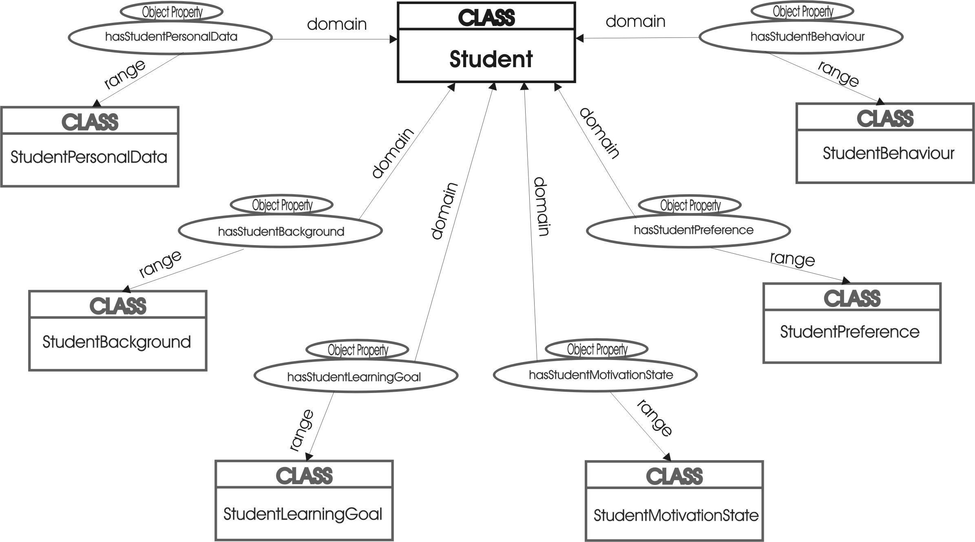

Fig. 1. Student ontology
Figure 1 depicts the main part of the described student ontology. Figure 2 depicts the internal structure of the ontological classes.

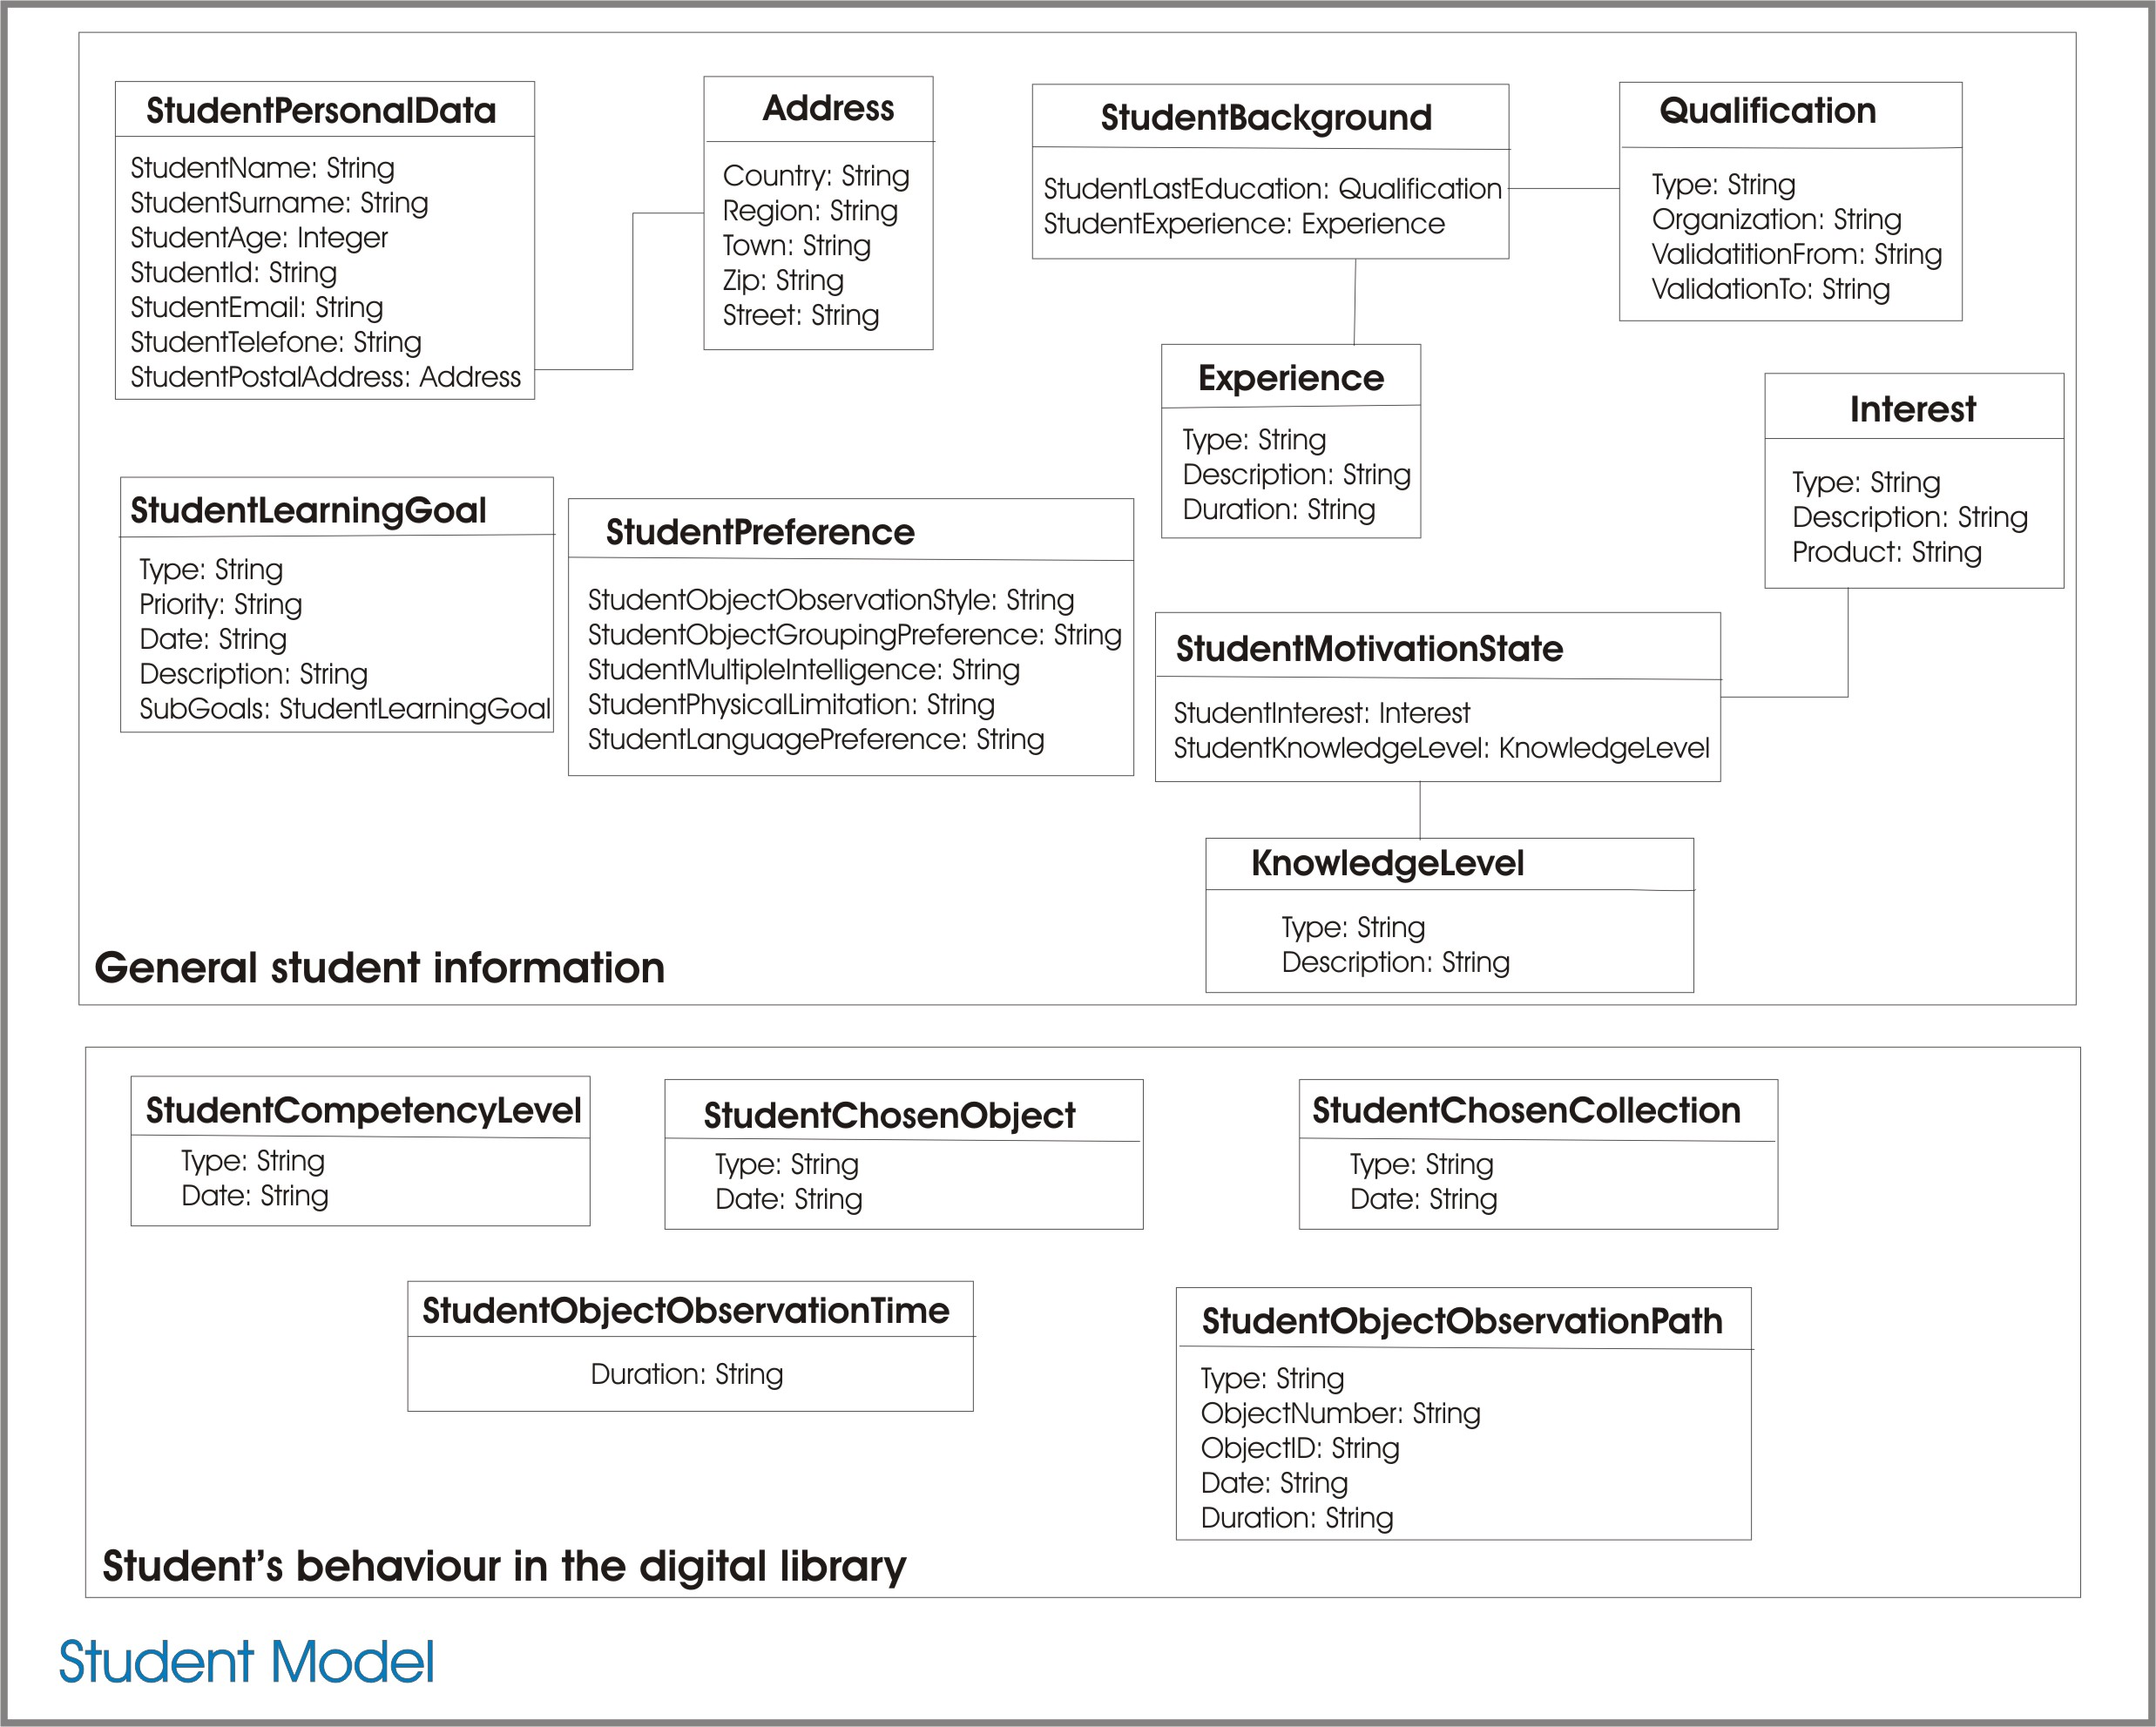
Fig. 2. Student ontology – class structure
To provide the relationships between two individuals from given classes, we define the relevant OWL object properties that are in several forms. Two of these forms are hasA and isAOf, where A is the name of some class or sub-class (for example, hasStudentBackground, hasStudentExperience, isStudentKnowledgeLevelOf, etc.). These two forms determine inverse properties i.e. if some property links individual p to individual q then its inverse property will link individual q to individual p. For example, hasStudentBackground and isStudentBackgroundOf are inverse properties. Every property has a domain and a range specified. The property links individuals from the domain to individuals from the range. For example, the property hasStudentPreference has the domain Student and the range StudentPreference. Other relationship forms are: Wishing, PreferringObjectGrouping, FollowingObjectObservationPath, etc.
In OWL, the properties are used to create restrictions. In our student ontology we use quantifier restrictions that are composed of a quantifier, a property, and a filler. The two quantifiers that we use are the existential quantifier () and the universal quantifier (). For example “ Wishing StudentObjectObservationStyle” is made up of the existential qualifier () the property Wishing and the filler StudentObjectObservationStyle.
Figure 3 depicts the StudentBackground class of the described student ontology. The student background is based on the student last education (StudentLastEducation) and his/her experience (StudentExperience). The last education is certified by any diploma or certificate with a written qualification type. This document is issued by a certain organization and usually has a validation period. The student experience implies type, description and duration.

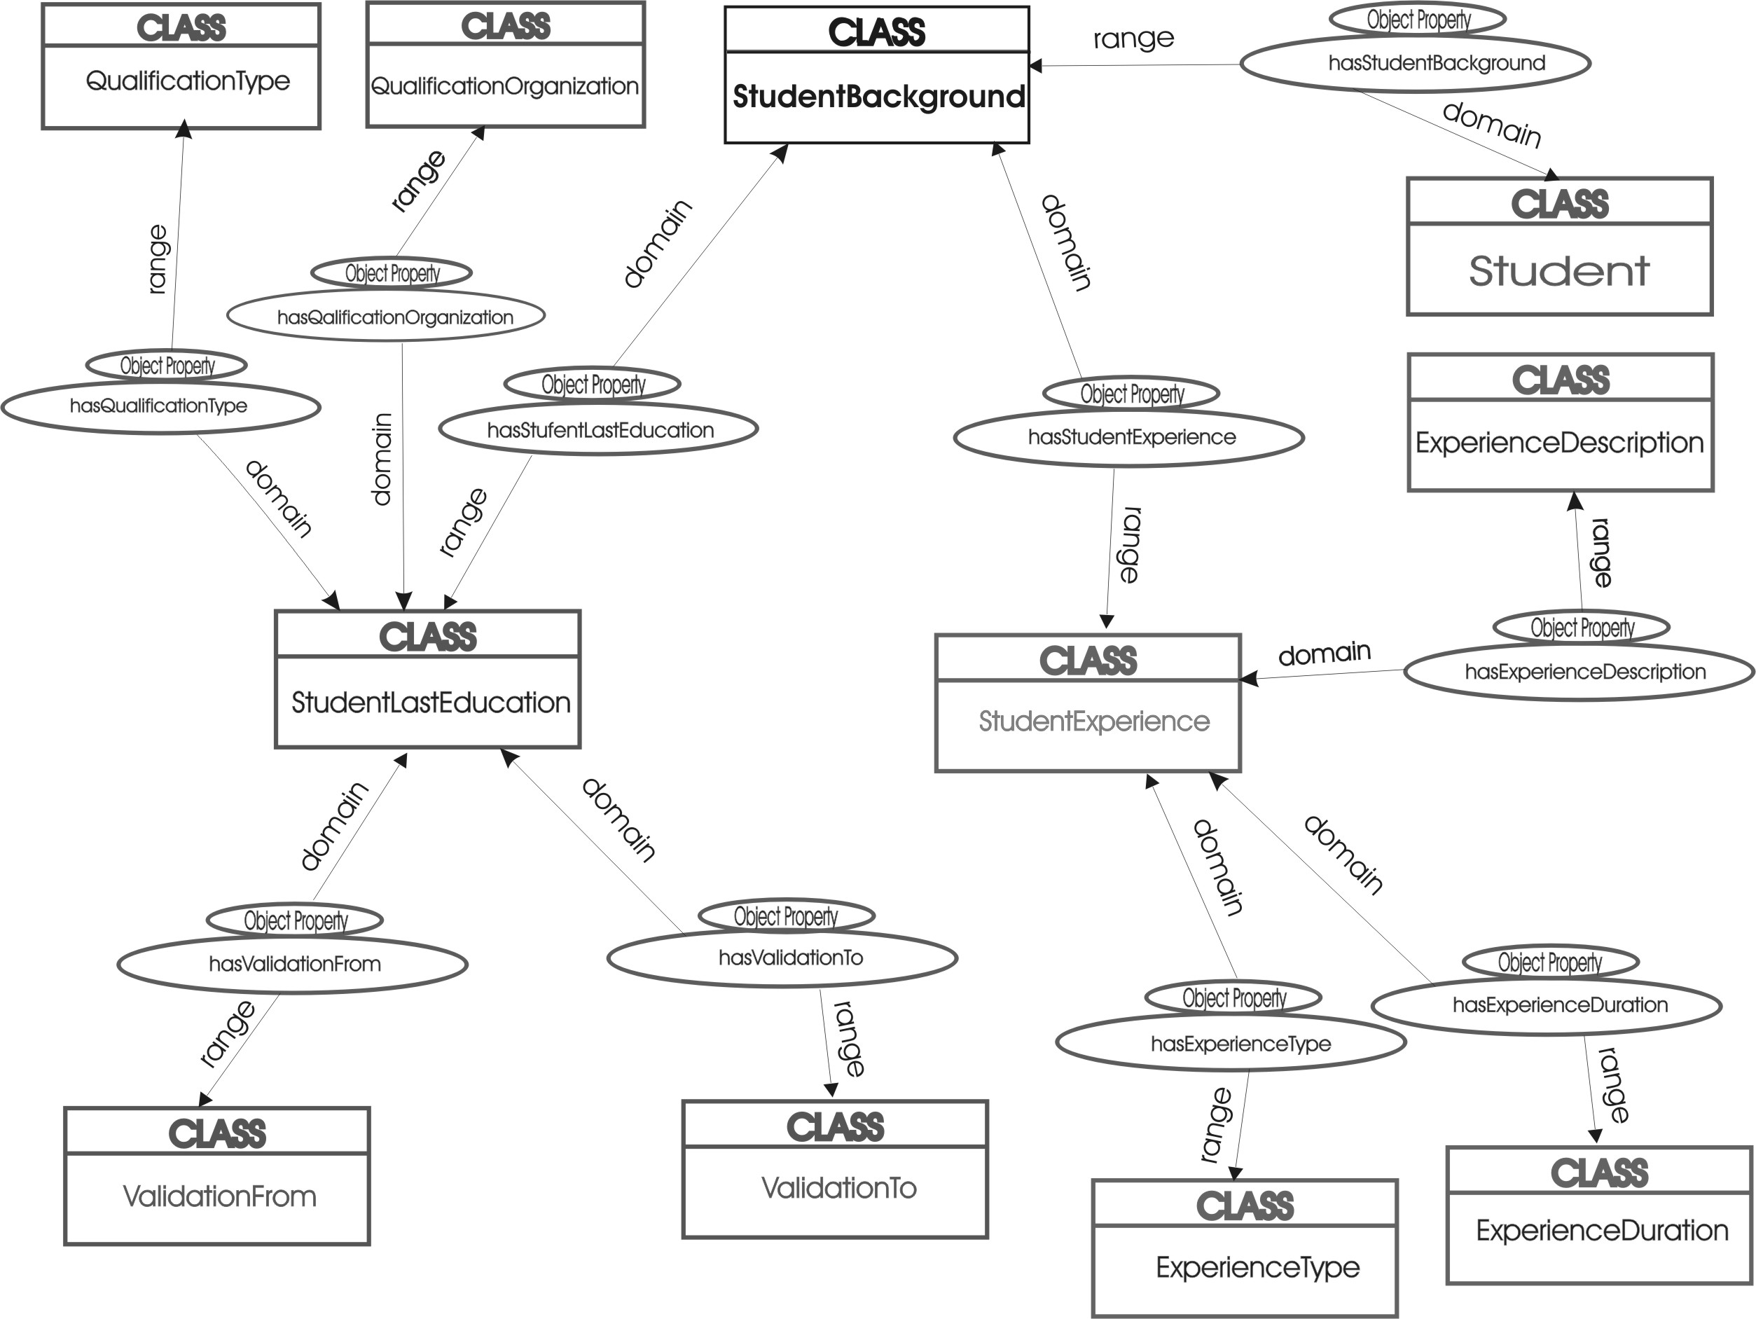

Fig. 3. Ontology for the student background
- Scenario for Implementation of student ontology
Search services (such as multi-feature search, multi-object search, personalized search, context-based search, etc.) in the multimedia digital library usually aids the visitors in finding certain digital objects. However, the software developers face a number of challenges and difficulties when trying to design and implement these services, especially when the target group of users is composed by students and not common viewers. Our current development is conducted on the idea to provide personalized and context-based search in a multimedia digital library to their users-students.
Let suppose that we have three types of students according to their knowledge level (StudentKnowledgeLevel - one of the main classes from the student ontology):
- First-level - students without special background;
- Second-level - students with special interest and good specialized knowledge in the MDL area;
- Third-level - researchers with high professional level of education in the MDL area.
Every student who wants to use the multimedia digital library as a source of digital knowledge has to be registered and classified according to its background information. Our student modelling ontology will be used as a tool for an ontological metadata description of the user's background, interests, wishes, object observation style, knowledge level, preferences, etc. For example, the class StudentObjectObservationStyle will describe what kind of description information is interesting and important for the student; StudentLanguagePreference include the preferable language; StudentChosenObject and StudentChosenCollection are two classes that contain information about user’s preferable objects and collections, with the class StudentObjectObservationPath the system traces the student’s object observation path, StudentInterest – areas of interest; StudentLearningGoal – learning objectives; StudentCompetenceLevel could keep student’s questionnaire results, if the MDL provides any questionnaire, etc.
For different student levels, the MDL search engine will show different description parts of the digital objects. For example, a first-level student will see the main description criteria of the search object. Moreover, if this first-level user has any special interests, wishes or preferences (StudentObjectObservationStyle, StudentLanguagePreference, StudentInterest, etc.) the search results will conform to them. During the registration process every user will determine the overall view of the digital objects (the object description information, available or not available images/video/sound, etc.) for their profile. The second-level student will see a more detailed object description, and the third-level students will have access to specialized knowledge with high difficulty, as needed for professionals.
The search results will be also context-based i.e. when the user searches by use of more than one criteria the MDL search engine will show not only the results that match all criteria simultaneously, but it will show additional groups of results i.e. other objects from the same criteria, etc. The class StudentObjectGroupingPreference from the student ontology will describe the grouping mode.
- conclusions and future work
In the last few years ontologies have become a silver bullet in the area of knowledge representation and knowledge modelling. The next generation of eLearning systems and applications and their main components – learning objects, student models, services, etc. cannot be developed isolated.
The student ontology for a digital library, which has been created and presented in this article, does not pretend to be fully comprehensive. To describe the object domain (student model) in detail, we have chosen only concepts, which can be matched to individuals easily and in a straightforward way. By joining the general student information and the information about student’s behaviour in the digital library, a student modelling application is better able to react to changes in student's type and behaviour during the knowledge observation process, which often happens in a long-time practice.
In maintaining the student model it has to be considered that the student does not perform consistently, student forgets information randomly and demonstrates large leaps in understanding.
In a next phase the student ontology for a digital library has to be mapped to the domain ontology. Ontology-based student modelling requires a referential structure, which in a chosen context needs to evolve according to the user’s progress, according to his new learning goals, domains of interest, which need to be acquired and updated (concepts like interests, preferences). A part of the general student information is dynamically changeable and is based on the achieved learning goal of the student and the review of his updated abilities. The information about the student’s behaviour in the digital library is naturally changeable, too and can be traced and used by the system to provide adaptive digital content and personalized knowledge flow/s.

References

- LTSC Learner Model Working Group of the IEEE (2000) IEEE p1484.2/d7, 2000-11-28 Draft Standard for Learning Technology - Public and Private Information (PAPI) for Learners (PAPI Learner), Technical report Available Online: http://www.edutool.com/papi/papi_learner_07_main.pdf
- Smythe, C., F. Tansey, R. Robson (2001) IMS Learner Information Package Information Model Specification, Technical report Available Online: http://www.imsglobal.org/profiles/lipinfo01.html
- Chen, W., R. Mizoguchi (1999) Communication Content Ontology for Learner Model Agent in Multi-Agent Architecture, In Proceedings of AIED99 Workshop on Ontologies for Intelligent Educational Systems
- Kay, J. (1999) Ontologies for reusable and scrutable student model, In Proceedings of AIED99 Workshop on Ontologies for Intelligent Educational Systems
- Heckmann, D., A. Krueger (2003) A User Modeling Markup Language (UserML) for Ubiquitous Computing, In Proceedings of the Ninth International Conference on User Modeling, Berlin Heidelberg: Springer 393-397
- OWL Web Ontology Language Overview. W3C Recommendation 10 February 2004, Available Online: http://www.w3.org/TR/owl-features/
- Self, J. (1990) Bypassing the intractable problem of student modelling. In C. Frasson & G. Gauthier (Eds.), Intelligent Tutoring Systems: At the Crossroads of Artificial Intelligence and Education. New Jersey: AblexChen
- Lane, C. (1998) Gardner’s multiple IntelligenceAvailable online: http://www.tecweb.org/styles/stylesframe.html
- Lane, C. (2000) Learning styles and multiple intelligences in distributed learning/IMS projects. 31 Segovia, San Clemente, CA 92672 (949) 369-3867, The Education Coalition (TEC)
- Sison, R., M. Shimura (1998) Student Modelling and Machine Learning. International Journal of Artificial Intelligence in Education 9, pp. 128-158

